Kevin Parsons
3138123
Abstract
Adapting a theoretical model developed by the Bank of Canada to determine whether low-income individuals alter behaviour based on the burden of holding coins.
Burden of Holding Coins for Low-Income Individuals
Term Paper for GECON 7303

Introduction
Despite several well-established alternative methods of payment to cash, it is still used for a large proportion of transactions. According to the Bank of Canada’s 2021 Method-of-Payments Survey Report, Henry et al. (2022), approximately 22% of transactions are conducted with cash, along with 4% of Canadians reporting being paid in cash by their employer during the past week and 13% having received cash from a friend or family member. While cash-use is declining, it is still an important payment method.
This paper recreates a theoretical model established by the Bank of Canada paper “Cash versus card: Payment discontinuities and the burden of holding coins” Chen et al. (2019), which “characterizes the choice between paying with cash and cards,” with a focus on exploring whether the observed burden of holding coins from that study holds for low-income Canadians. To do this, rather than using data from the 2013 Bank of Canada Method-of-Payments Survey, this paper uses data collected in Phase I of the Canadian Financial Diaries project. The methods employed to collect this data is outlined in “Canadian Financial Diaries Methods Report on Phase I” by Dueck-Read et al. (2019) and the use of the data for this paper was provided by one of Dueck-Read’s coauthors, Dr. Jerry Buckland.
While broad conclusions about the general population of low-income individuals can’t be drawn from the 28 participants included in the data set used in this paper, it is worth noting there are some differences compared to the results reported in Henry et al. (2022). First, the observed transactions in the low-income data set paid with cash about 26.5% of the time, compared to 22% found with the Canadian population. Second, 75% of low-income participants had a credit card, compared to 87% of Canadians, signaling this group had fewer payment options than average. While too little is known about the financial habits of low-income individuals to be able to consider the individuals in this data set a representative sample, higher cash use and lower access to credit cards provides motivation to compare these results to those of Chen et al. (2019).

Model and Predictions

Assumptions
As with the Bank of Canada’s Chen et al. (2019) study, there are aspects of the data that forces a few assumptions that are reasonable, but still should be noted. For this reason, the model is used to examine if there is a reasonable probability that cash use declines for transactions that are up to $0.95 greater than the nearest banknote value, compared to the $0.95 less than the nearest banknote value. Regression discontinuity design (RDD) is used to do this.
Ideally, the data would include information such as cash-on-hand at the time of the transaction, as well as the exact amount of change provided after the transaction. Since this information is not available, the first assumption is that consumers prefer to carry a “light wallet” rather than a “heavy” one. For this study, a “light wallet” is defined as a consumer carrying banknotes and large coins ($1 and $2).
The data used in this study is from Canada, where there are no longer pennies ($0.01 coins) in circulation, and because of this any cash transactions are rounded to the nearest $0.05. The small coins available have the denominations of $0.05, $0.10, and $0.25. Another assumption is that consumers always received the most efficient number of small coins for change after a transaction. For these amounts see Figure 1. Additionally, receiving change after a cash transaction is assumed to always be an option. Essentially, the model assumes that the method of payment is completely determined by consumer preference, rather than any decision that the merchant makes.
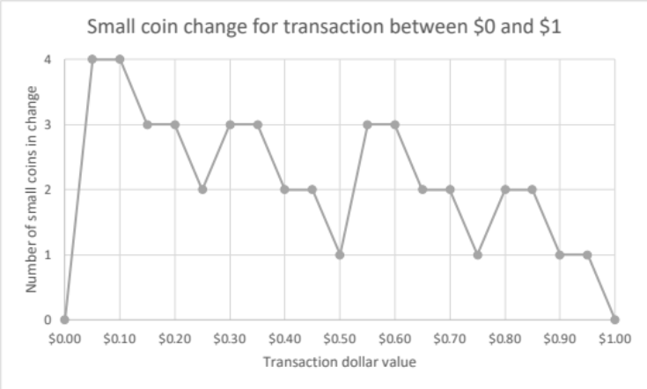
Figure 1. Notes: The most efficient number of small coins needed to provide change on a transaction value between $0 and $1.

Along with any small coins received as change, it is assumed that banknotes and large coins may be needed. However, since it is assumed that there is no “burden” to carrying banknotes, the large coins can be included to show the assumed cost of paying in cash, shown in Figure 2.
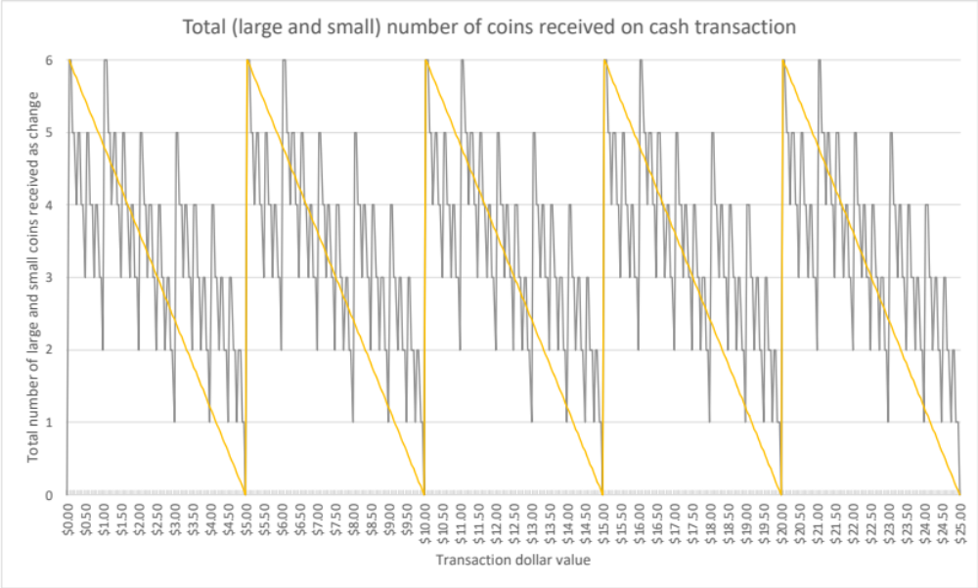
Figure 2. Notes: The total number of large and small coins received in change in a cash transaction. The yellow line shows the general downward trend in the number of coins received, with a sharp jump after an amount that is the exact combination of banknotes.

Model
As per the methodology used by Chen et al. (2019) small coin denominations in Canada can be considered a series of “small jumps” for the sake of the model, the downward trend is used to establish the RDD discontinuities, following Angrist and Lavy (1999). The model examines the discontinuities in cash usage around transaction values of $5, $10, and $20. Recognizing that while there is a downward trend in the number of coins received as change in cash transactions as the value approaches that of a banknote, there is variation. However, the largest jump in coins received occurs between the value of a banknote and a transaction $0.05 greater than that value (for example, $5 and $5.05).
To examine the relationship between paying cash and the value of the transaction, two different models are used. First, to examine transactions in the “narrow window” around the value of a banknote, we use
$$C=β_{0}+β_{1}a+β_{2}a^{2}+δ_{v}I\left(a>v\right)+u$$
Where $P$ is a binary variable indicating the use of cash, $a$ is the amount of the transaction, and $v$ is the value of the banknote being examined. Specifically, the models used are:
$C=β_{0}+β_{1}a+β_{2}a^{2}+δ_{5}I\left(a>5\right)+u$ with $a∈(4.05, 5.95)$ (1)
$C=β_{0}+β_{1}a+β_{2}a^{2}+δ_{10}I\left(a>10\right)+u$ with $a∈(9.05, 10.95)$ (2)
$C=β_{0}+β_{1}a+β_{2}a^{2}+δ_{20}I\left(a>20\right)+u$ with $a∈(19.05, 20.95)$ (3)
A fourth model including all transactions and values of banknotes was also included:
$C=β_{0}+β_{1}a+β_{2}a^{2}+δ_{5}I\left(a>5\right)+δ_{10}I\left(a>10\right)+δ_{20}I\left(a>20\right)+u$ (4)

Prediction
Since the low-income individuals included in the study pay with cash in a slightly higher proportion of their transactions, I predict that it is possible that the “burden of holding coins” will not be observed in this sampling. My reasoning for this is that this simplified model of method of payments decision making assumes that there is essentially no cost in debit or credit transactions, which is not true in the real world. First, the individuals in this sample do not have the same availability of credit cards as the general population. Second, there is a cost to debit transactions that may prevent these individuals from relying on using their debit cards regularly.

Data
The data used for this study was collected as part of the Canadian Financial Diaries Research Project, Dueck-Read (2019), with access given by researcher Dr. Jerry Buckland. There are some notable differences from the Method-of-Payments Survey data used by the Bank of Canada in their analysis.
First, the Method-of-Payments Survey (MOP) is a general survey that is meant to sample a cross-section of the Canadian population to analyze consumer behaviour, while the Financial Diaries (FD) is a project to better understand the financial habits of low-income individuals. As such, the FD data is collected from a small number of people, 28 in this instance, all of whom are from Winnipeg, MB and would be considered on the lower end of the distribution of Canadians’ incomes.
Additionally, the MOP asks subjects to record their transaction information over a three-day period, while the FD data gather process lasted up to a year, with participants recording their transaction data as well as a monthly interview being conducted by a researcher. FD participants were compensated, but not an amount that would be likely to significantly change their spending habits. However, this does call into question if there is a selection bias for participants, but since this paper is addressing method of payment habits for these individuals, using detailed transaction information, it is not clear that any selection bias would have a significant effect on the findings reported in this paper.
Overall, while the data collection methodologies are quite different, the observed variables of interest for this model are the same. As with all survey results, there may be a question of accuracy, but this is the most complete data set available for the financial habits of low-income individuals available to be used in this paper.

Summary Statistics
The financial transaction information was collected through 2018 and 2019, with participants starting/stopping at different times, due to the recruitment process used. On year of data was collected, along with demographic information about the participants. Summarized, the dataset includes the following:
Table 3.1
 | Number | Mean Value
All Transactions | 13,669 | $99.48
Cash | 638 | $37.35
Debit Card | 807 | $82.88
Credit Card | 7 | $42.64
Other | 12,217 | $212.00

Empirical Results
Examining the data, it does appear as though there is a discontinuity in cash use for values greater than banknote denominations, where the individuals included in the study are less likely to use cash above the banknote value. Figure 3 shows the regression discontinuities plotted on in the “narrow window” around the values of banknotes.
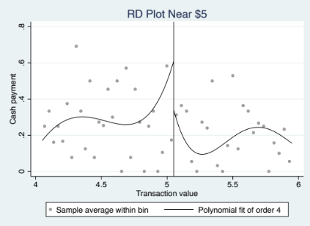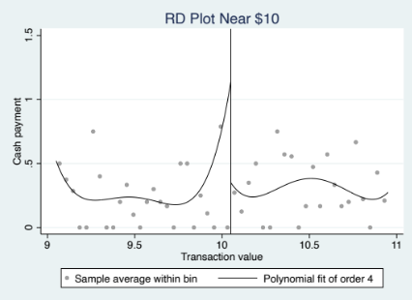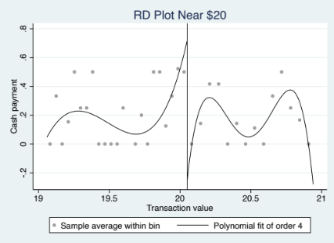
Figure 3. Regression discontinuity design at three thresholds. Notes: Created using the rdplot command in STATA. Threshold set at 0.05 above the value of the banknote in the range (5.05, 10.05, and 20.05 in the respective graphs).

Further supporting this finding, Table 1 displays the regression results for the models specified in section 2.2.

Table 4.1
Regression discontinuity design estimates of cash denomination thresholds
 | Narrow Window |  |  | All Transactions
 | (1) | (2) | (3) | (4)
Constant | -3.555***  (1.1223) | -39.727***  (7.228) | -112.944**  (46.591) | 1.019***  (0.0327)
Purchase amount | 1.369***  (0.442) | 7.560***  (1.456) | 11.090**  (4.707) | -0.000285***  (0.0000192)
Purchase amount squared | -0.112***  (0.0434) | -0.351***  (0.0734) | -0.271**  (0.119) | 3.63e-8***  (4.77e-9)
Threshold at $5 | -0.402***  (0.0382) |  |  | -0.129***  0.0188)
Threshold at $10 |  | -0.616***  (0.0552) |  | -0.437***  (0.0151)
Threshold at $20 |  |  | -0.336***  (0.0861) | -0.195***  (0.0218)
n | 1,271 | 1,065 | 493 | 13,665
R² | 9.45% | 20.09% | 8.44% | 8.75%
Notes: The dependent variable is the binary choice by the consumer whether to use cash for a particular transaction, with standard errors reported in the brackets. *, **, and *** denote the results’ significance level at 10%, 5%, and 1% respectively.

Results from all the values of the included regressions are significant at least a 5% confidence level. However, it is worth noting again that these results should not be interpreted as the magnitude of preference, but rather exemplifying a trend.

Omitted Variable Bias
Since consumer behaviour is complicated, there is a significant probability that simple models such as these suffer from omitted variable bias. Using Ramsey’s (1969) regression specification error test (RESET), which according to Wooldridge (2020) is a useful test for general form misspecification. Using the ovtest command in STATA, the results indicate that it is probably that all reported models suffer from misspecification, likely due to omitted variables.
Due to the limitations in the data used, there are no additional observed variables that would be useful to the model. However, evidence of omitted variable bias does not necessarily mean that the overall result of the model, that individuals are less likely use cash for transactions just above the value of a banknote, is incorrect. It is further evidence that the results should be viewed as an overall decrease in probability of a cash transaction, but not quantifiable.

Results Not Reported
I also attempted to examine if there was a relationship between cash payment and sex, with the specific hypothesis that females may be less likely to pay in cash, due to safety concerns about carrying cash. This is motivated by qualitative data shared by Dr. Jerry Buckland in a conversation, with one of the female subjects stating that she did not feel comfortable carrying large amounts of cash and that influenced her method of payment behaviour.
However, after adding a dummy variable indicating sex, there were not statistically significant results. I think a plausible for this result could be that it is because there were far more female subjects in a relatively small sample of individuals in the study (23 out of 28 participants identified as female, see Table 2 in the References section). A second reason could be that the transaction values have been studied would not be considered a large amount of cash. It is for these reasons that I don’t think any conclusions should be drawn from my results and it is likely worth further study in this area, therefore I am not including them in this paper.

Conclusion
Using the available low-income data, I was able to recreate the “burden of carrying coins” that the Bank of Canada observed using the Methods-of-Payment survey. As previously discussed, more research would be needed before being able to declare with any confidence that this observation is universal. However, the finding holding for this sample of low-income households is still notable, especially considering that the sample included a greater-than-average proportion of cash transactions when compared to the general population included in the Methods-of-Payments Survey.
There are several possible reasons for this, the first being that the Methods-of-Payment survey does not include a complete cross-section of Canadians, most notably excluding individuals who would be considered low-income. A major implication of this is that the Bank of Canada is possibly making policy decisions regarding physical money availability that does not fully consider all Canadians, due to this potential lack of data.
For policymakers, this result may be of importance regarding access to financial services regulation. If an individual is less likely to use cash for transactions up to $1 more than a banknote denomination, then they are obviously using a different method of payment, the most common of which are debit and credit cards. As previously stated, the households that are part of this dataset are less likely to have access to a credit card, which means they are then most likely using a debit card for these transactions. An issue that arises with debit cards is that the “affordable banking” account option typically has a limit on the number of transactions that are included in the monthly fee, with fees being levied for additional transactions. These fees can add strain to an already tight financial situation.
Overall, not enough is known about the financial habits of low-income individuals, which effects the quality of the policies that are meant to provide opportunities to improve their financial situation. With this paper suggesting that it’s possible that the burden of holding coins lowers the probability of cash being used in a transaction, at the very least low-income people must have easy access to other methods of payment, which may not always be the case, as exemplified by a lower proportion of participants in the study having access to credit cards as the general Canadian population. These considerations and more are vital to ensure the improved participation by low-income people in the increasingly digital financial system, giving them the opportunity to improve their financial situation.

References
Henry Christopher S., Huynh Kim P., Shen Q. Rallye; “2013 Methods-of-Payment Survey Results” (2015); Bank of Canada Discussion Paper

Henry Christopher, Shimoda Matthew, Zhu Julia; “2021 Methods-of-Payment Survey Report” (2022); Bank of Canada Staff Discussion Paper

Dueck-Read Jodi, Buckland Jerry, Janzen Maya, Rani Isha; “Canadian Financial Diaries Methods Report on Phase I” (2019); Posted on the Canadian Financial Diaries website; https://financialdiariesca.files.wordpress.com/2019/09/diaries-methods-report_public.pdf

Canadian Financial Diaries; https://financialdiaries.ca/home-2/; Accessed on April 7, 2023

Chen Heng, Huynh Kim P., Shy Oz; “Cash versus card: Payment discontinuities and the burden of holding coins,” Journal of Banking & Finance, Volume 99, 2019

Wooldridge, Jeffrey M. Introductory Econometrics : A Modern Approach (version Seventh edition.). Seventhed. INSERT-MISSING-SERVICE-NAME. Victoria, Australia: Cengage, 2020.

Ramsey J. B.; “Tests for Specification Errors in Classical Linear Least-Squares Regression Analysis,” Journal of the Ryal Statistical Society. Series B (Methodological) Vol. 31, No. 2 (1969)

Angrist, J., Lavy, V.; “Using maimonides’ rule to estimate the effect of class size on scholastic achievement,” Q. J. Econ. 114 (2) (1999)

Table 2
A summary of the number of weeks of data recorded per financial diaries participant, as well as their gender.

Duration | Gender
52 | Female
52 | Female
52 | Female
52 | Male
52 | Female
52 | Female
52 | Female
52 | Female
52 | Male
52 | Female
52 | Female
52 | Female
52 | Female
52 | Female
52 | Female
52 | Female
52 | Female
52 | Female
22 | Female
21 | Male
52 | Female
29 | Male
52 | Female
52 | Female
52 | Female
52 | Female
16 | Female
52 | Male

https://www.bankofcanada.ca/wp-content/uploads/2015/04/dp2015-4.pdf
https://financialdiaries.ca/home-2/
It’s worth noting that the 2021 Methods-of-Payment Survey was completed during the COVID-19 pandemic, while the Financial Diaries data was collected prior to its start. This may have contributed to the difference in cash use and more will be known about Canadian’s cash payment habits following the next Methods-of-Payment Survey.

